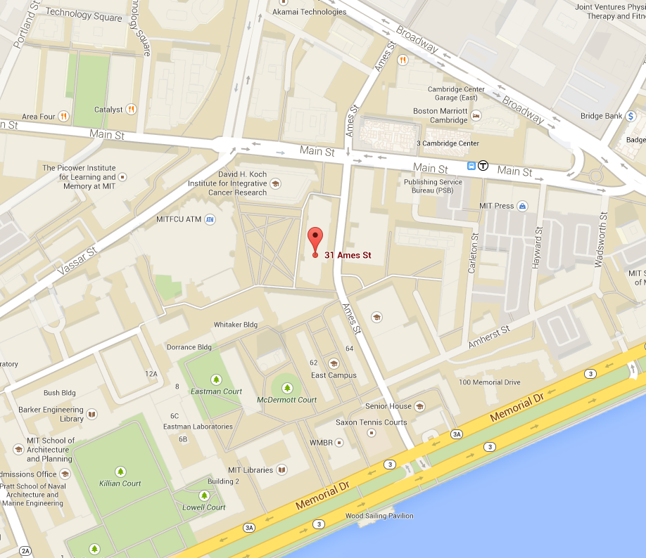
AEE Spring Round Table
Directions and Parking

The Round Table will be held at MIT,
31 Ames Street, Room 68
Cambridge, MA.

Room 68 is located just to the right
as you enter the front door on the
First floor.

31 Ames Street is the biology building.

Please note that parking is very limited in this area.

The building is just a few blocks from
The Kendall Square T Stop on the Red Line.

Access to the Red Line with parking is at South Station
And the Alewife T Stop.

Please note that the Longfellow Bridge is closed going from Boston to Cambridge.

Parking lots and garages are:
One Kendall Square Garage, 1 Kendall Square, Cambridge
Standard Parking Garage, 800 Technology Square, Cambridge
Hayward Parking Lot, Hayward Street, Cambridge

